NTHU Counseling Center, One Day English Workshop in May 16,2025!!
Theme: Strengthen The Mind-Body Connection
¤Morning session: Activate Your Mind and Body: The Power of Exercise
for Academic Excellence (NTHU Physical Education Teachers)
¤Afternoon session: Bodily Inside Out. (Dance/Movement Therapist)
Welcome all International Students. Maximum number: 20 students. Last day to register is April 28. Please email to tshlee@mx.nthu.edu.tw.
Date & Time: May 16, Friday, at 9:00am.-15:50pm.
Location: 1F&2F, Counseling Center NTHU (Main Campus)
Morning session at 9:00-12:00
Activate Your Mind and Body: The Power of Exercise for Academic Excellence
Lecture Introduction:
Modern research has demonstrated that regular physical activity not only promotes physical health but also significantly enhances memory, concentration, and overall cognitive performance. As international graduate students pursuing master's or doctoral degrees, you may often feel overwhelmed by academic pressures, face challenges in memory retention, or neglect your overall physical and mental well-being. This lecture will explore how regular exercise can improve academic efficiency, boost memory function, and alleviate stress associated with intensive studies. Additionally, we will share practical strategies for managing mental and physical health, including stress-relief techniques, nutrition and sleep advice, and easy-to-follow home exercise routines, assisting you in maintaining optimal health.
To provide a clearer understanding of your physical fitness, we will introduce the significance and procedures of fitness assessments, including practical demonstrations and guidance. Furthermore, the session includes a tour of the university's sports facilities and equipment to help you effectively utilize campus resources for maintaining consistent physical activity.
We warmly invite you to participate, activate your brain through exercise, enhance your physical and mental health, and energize your academic and research journey!
Instructors:
Name: Chiang-Hao Fan 范姜顥 (Adjunct Lecturer)
Specialization: Table tennis, Sport/Exercise Sociology
Education: Ph.D., Graduate Institute of Sports, Leisure, and Hospitality Management, National Taiwan Normal University
Name: Te-Chuan Chiu 邱得全 (Lecturer, Head of Athletic Activities Team)
Specialization: Volleyball
Education: Taipei Municipal University, Graduate Institute of Physical Education

Afternoon session at 12:50-15:50
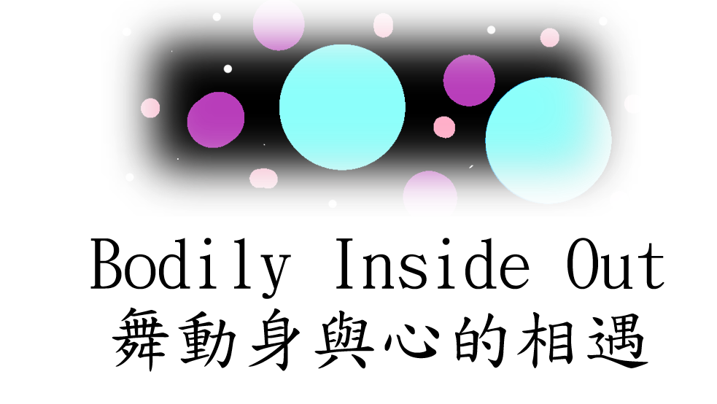
The body and mind are inseparable. Dance therapy is the therapeutic use of movement, dance, body awareness, and embodied communication to support healing and well-being for individuals, groups, and communities. No dance experience is needed—just bring your curiosity and openness to explore a bodily approach to self-care.
Let’s take a BREATH together:
🔹 Breathing – Discover your own unique rhythm of breath.
🔹 Regulation – Balance energy and emotions through group activities.
🔹 Expanding – Broaden your movement repertoire and embrace flexibility.
🔹 Awareness – Deepen your understanding of the body-mind connection.
🔹 Tenderness – Cultivate compassion and kindness.
🔹 Happiness – Find joy both individually and in shared experiences.

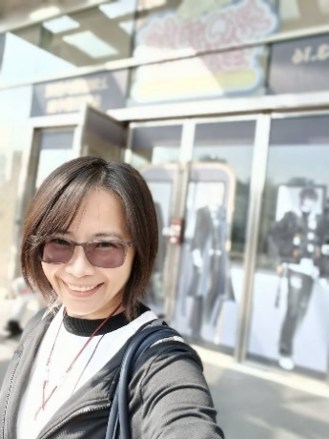
Come move, connect, and breathe with us!
Pei-Shan Tsai is currently a full-time counseling psychologist at National Formosa University. She received her Master's degree in Dance/Movement Therapy from Columbia College Chicago in the US, and has since worked in a variety of settings such as universities, hospital, community and correctional institutions in Chicago and Taiwan as a dance therapist, counseling psychologist, lecturer and supervisor. Her passion is helping clients and trainees use creative movement expressions and process to connect with their authentic selves. She has focused her research on the Self-Awareness Supervision Mode with a body-mind approach, dance therapy groups for inmates in detention center, and the development of a movement experience observation scale.
~~~~~~~~~~~~~~~~~I would like to sign up!!!!~~~~~~~~~~~
Name: Nationality:
Department: What year are you in?
Undergraduate OR Graduate Students?
Student ID:
~~~~~~~~~~WE welcome you to join us!!~~~~~~~~~~~
Please email to tshlee@mx.nthu.edu.tw before April 28,2025. Counseling Center, Office of Student Affairs, NTHU

