2026年國立清華大學短期海外訪問獎(Short Overseas Visit Scholarship)印領清冊-領據Receipt
學院  College |  | 系所  Dept | 姓名  Name | 學號  Student ID | 全球處補助核定額 | 訪問日期  date | 同學簽名  Signature
院 |  | 系 |  |  | 新臺幣20,000元 | 20 / / -  20 / / .

- 一次性撥付新臺幣2萬元獎學金。若同學無法順利完成返國義務（因故退學、未繳交心得報告、未繳交機票等文件），需依規定繳回。A one-time scholarship of NTD 20,000 will be disbursed. Students who fail to fulfill the post-return requirements (e.g., withdrawal from the university or failure to submit the report or flight ticket documents, etc.) must repay the scholarship in accordance with the regulations.
- 申請同學需同意，不得以同樣單據申請相同事由獎學金。如已撥付相關獎學金，應依相關規定辦理支出收回程序。Applicants may not use the same supporting documents to apply for scholarships for the same purpose. Any scholarship already disbursed must be repaid in accordance with applicable regulations.
- 紅框無須填寫，由全球處填寫。Fields outlined in red are for OGA use only.
- 請同學依規定時間自行將本表單印出親簽，並黏貼憑證後送至全球處全球學術合作組古小姐；並將心得報告內容email至古小姐lingyu.ku@mx.nthu.edu.tw。Print and sign this form, attach the required supporting documents, and submit it to Ms. Ku at Division of Global Academic Collaboration, OGA by the deadline. Email the report to lingyu.ku@mx.nthu.edu.tw.

來回機票票根或電子機票或其他足資證明行程之文件照片(正本或影本)黏貼處Round-Trip Ticket Stubs, E-Tickets, or Other Travel Documents (Original or Copy)

示意圖，可覆蓋/刪除Example only; may be covered or deleted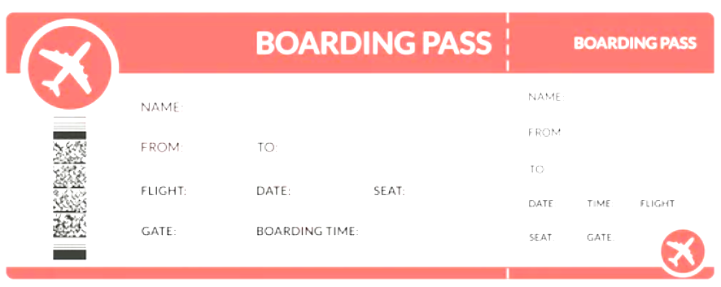ed.

購票證明單或旅行業代收轉付收據之正本或影本黏貼處（需可顯示姓名，並與機票、申請書等一致）
Ticket Purchase or Travel Agency Receipt (Original or Copy) (The passenger’s name must be clearly visible and consistent with the name on the flight ticket, application form, and other documents.)

示意圖，可覆蓋/刪除Example only; may be covered or deleted.

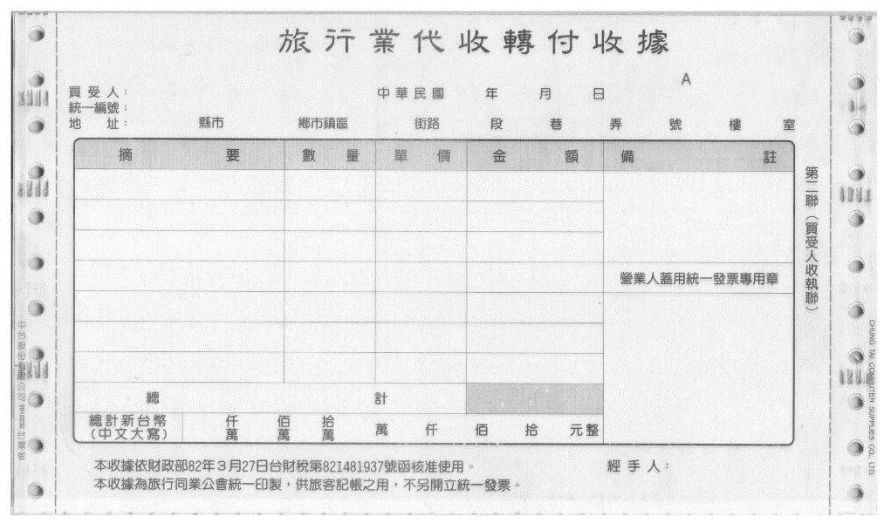

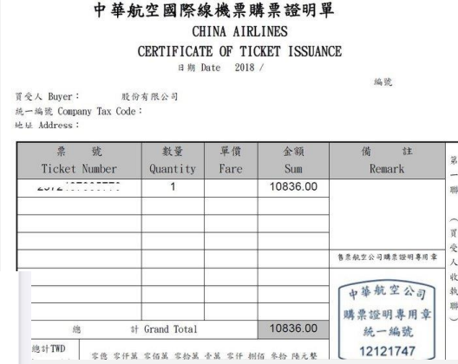

附件3
國立清華大學學生「短期海外訪問獎」心得報告內容大綱

請於封面上方列標題（標題內容須含：選送生獲補助年度、薦送學校、系所、年級、中文姓名、前往國家、單位、國外研修成績或研究單位評語）

獲補助年度 | 2026
薦送學校、系所、年級
中文姓名
研修國家
研修單位
一、緣起
二、研修單位簡介
三、國外研修之專業學習（課內）
四、國外研修之生活學習（課外）
五、研修之具體效益（請條列式列舉）
六、感想與建議
※至少須包含四張（含）以上照片

Annex 3
NTHU Student Short Overseas Visit Scholarship
Experience Report Outline

Please list the title at the top of the cover page. Department, grade, Chinese name, country, institution, foreign study results or comments from the research institute)

Subsidized Year | 2026
Date of visiting
Referral School, Department, Grade
Chinese Name
Visiting Country
Visiting Institution
I. Origin
II. Introduction to the visiting institution
III. Professional study (In-class)
IV. Life of study (extracurricular)
V. Specific benefits of the training (listed in the form of a bar)
VI. Reflections and suggestions

At least four (4) photos must be included

